**Washing Machine Status Tracker**

***Database Management Systems - Project***

**Group Members:**

CS22B1010-T.S.M THRIVEEDH

CS22B1099-B. SIDDHARTHA REDDY

CS22B2019-H. SAI SANDEEP

CS22B2023-T. SAI MADAN

CS22B2020 - G. SRI RAM



**Contents:**

**1 Introduction**

* 1. **Purpose**
  2. **Intended Audience**
  3. **Project Scope**

1. **Overall Description**
   1. **Functional Requirements**
   2. **Non-functional Requirements**
2. **System Features**
   1. **Technology Stack**
   2. **System Requirements**
3. **Frontend**
4. **Database**
5. **Queries**

**1 Introduction**

**Purpose:**This project allows students to efficiently manage their laundry without disturbing their schedules, reducing waiting time by being the one-stop solution for all laundry problems. Automation ensures that washing machines are utilized optimally, ensuring smooth operation for all users.**Intended Audience:**This project is particularly beneficial for hostel and PG students, catering to environments where the number of washing machines is limited compared to the high demand among the student population.**Project Scope:**This project is aimed at providing students with real-time updates on the status of individual washing machines, making it easier for them to see which ones are available whenever they need to do their laundry.Additionally, there will be an administrative dashboard specifically designed for authorized personnel. This dashboard will allow them to update the status of the washing machines and handle any complaints that may arise.It’s worth mentioning that this project won’t include any advanced featureslike booking systems or remote-control capabilities for the machines.**2 Overall Description**

**2.1Functional Requirements:**

* **User Authentication and Authorization:**The system shall provide user authentication mechanisms to verify the identity of users accessing the system. Authorized users, such as staff and administration, shall have specific roles and permissions to perform certain actions within the system.
* **User Logging:**The system shall log user interactions with the washing machines to maintain usage history. User interactions to be logged include the student’s roll number and the machine ID they are using.

The logged information shall be stored securely and tamper-proof to ensure data integrity and traceability. Access to user logs shall be restricted to authorized personnel, such as administration and system operators.

* **Real-time Monitoring:**

The system shall continuously monitor the status of each washing machine in real-time, including availability, current usage, and maintenance status**.**

* **Admin Interface:**The administrative dashboard shall provide authorized personnel with the ability to manage washing machine information and update statuses. Admins shall have the capability to view user log details.

**2.2 Non-functional Requirements:**

* **Performance:**The system must efficiently handle concurrent requests from multiple users without experiencing significant performance degradation
* **Availability:**The system should be available for use 24/7 with minimal planned down-time for maintenance or updates, ensuring uninterrupted service for users**.**
* **Security:**

Robust security measures must be implemented to protect user information. This includes the implementation of authentication and authorization mechanisms to control access to system resources and safeguard sensitive data.

* **Usability:**The user interface must be intuitive and user-friendly, featuring clear navigation and layout to facilitate ease of use for all users. This includes providing straightforward access to features and functionalities to enhance the overall user experience.
* **Maintainability:** The system should be designed with modular and well documented code to facilitate ease of maintenance and accommodate future enhancements. This ensures that updates and modifications can be made efficiently without compromising system integrity or functionality.
* **Compatibility:**The system is designed to support common web browsers and ensures seamless compatibility across a variety of platforms, ensuring accessibility and usability for all users, regardless of their preferred device or operating system.

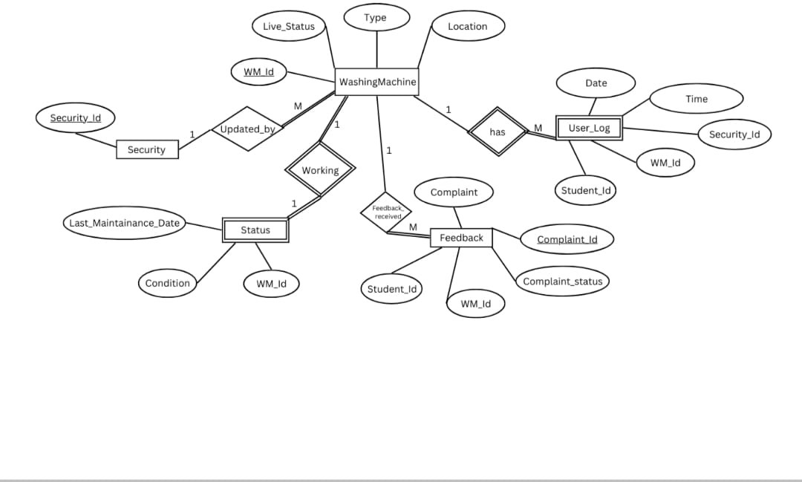

**ENTITY RELATIONSHIP DAIGRAM**

**3 System Features**

* 1. **Technology Stack:**

**Frontend Technologies:**

* **HTML:** Used for creating the structure and content of web pages**.**
* **CSS:** Employed for styling and ensuring a responsive, visually appealing interface.
* **JavaScript**: Utilized for client-side scripting to add interactivity and dynamic behaviour.

**Backend Technologies:**

* **Node.js:** A JavaScript runtime environment for building the server-side application, known for handling multiple concurrent connections efficiently.
* **Express.js:** A web application framework for Node.js, used for routing, handling HTTP requests, and integrating middleware.
* **Pg:** A PostgreSQL client for Node.js that facilitates communication with the database**.**

**Database Technologies:**

* **PostgreSQL**: An open-source relational database management system used to store and manage all application data, offering features like ACID compliance and support for complex queries.
  1. **System Requirements:**

Works on any operating system.Internet connection is required.Works on any browser.

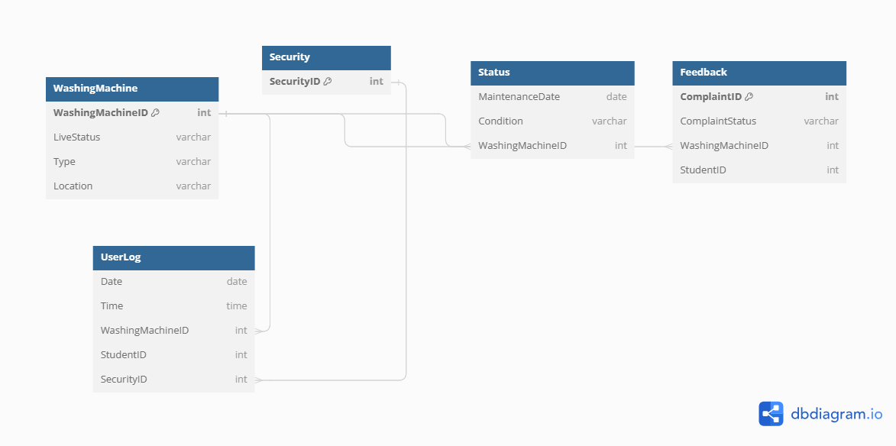

**SCHEMA**

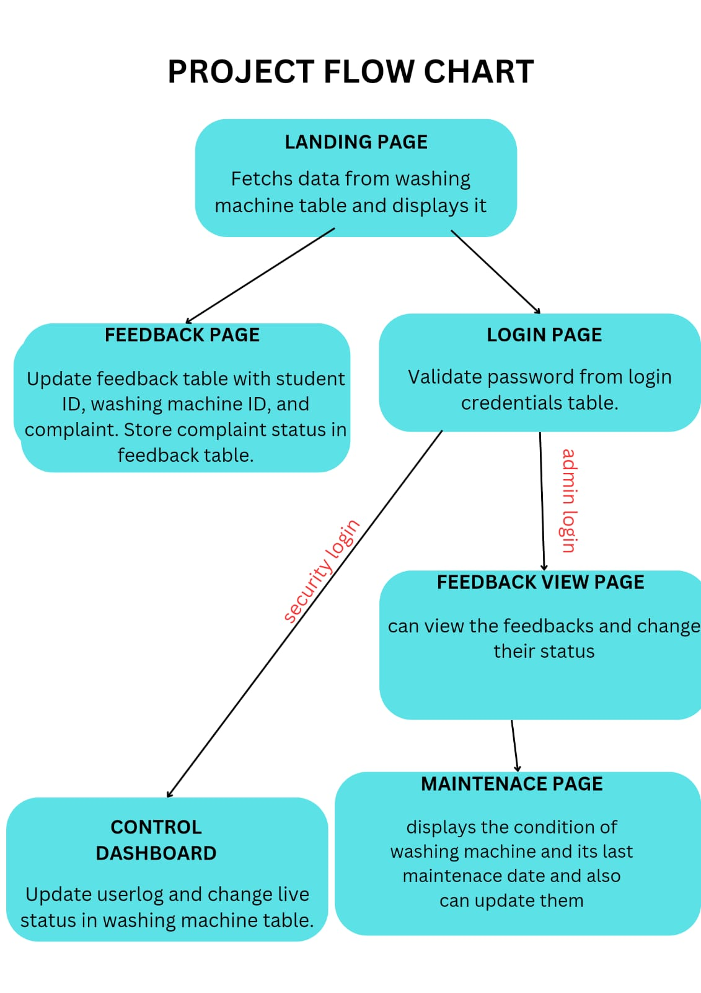

1. **Frontend**

**Landing Page:**

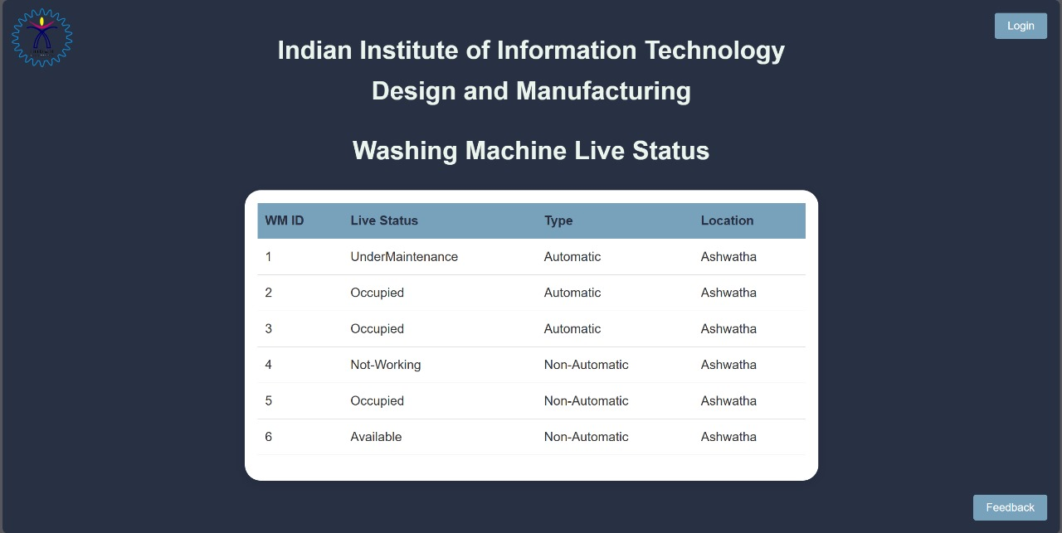

**Login Page:**

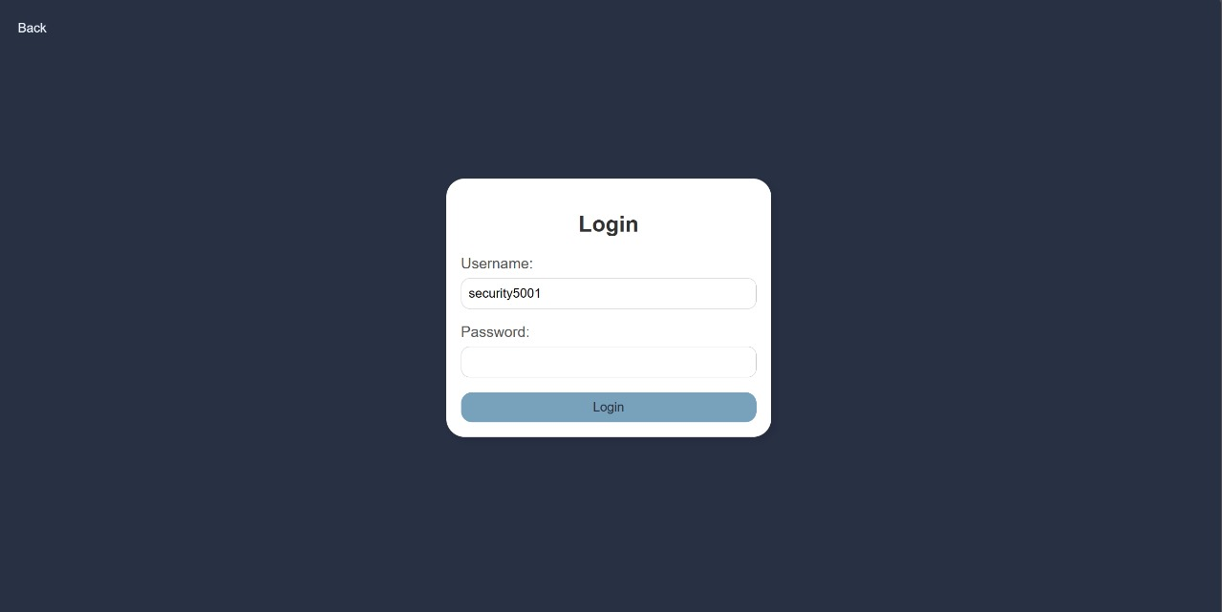

**Feedback Page:**

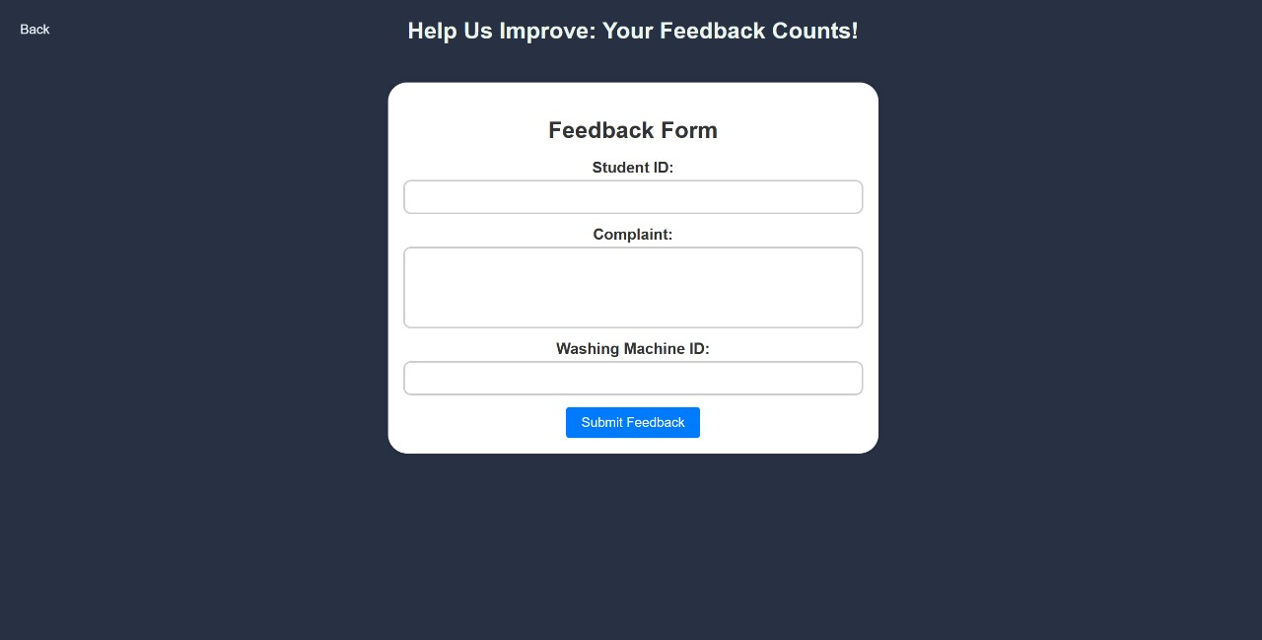

**Live Status Updating Page:**

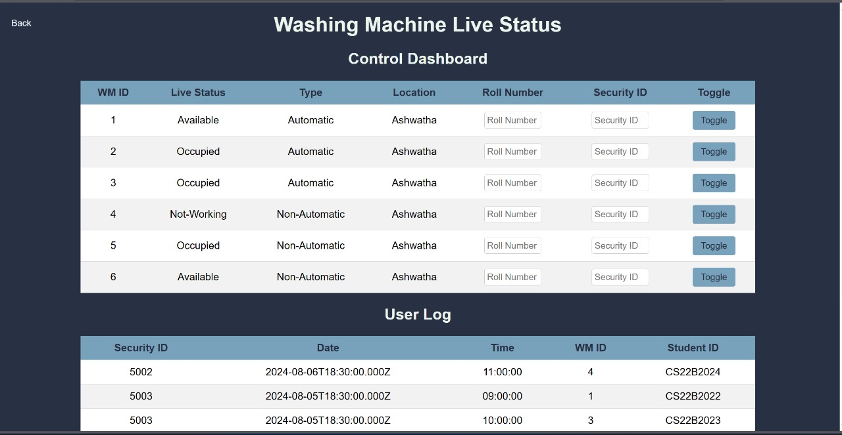

**continue..User Log:**

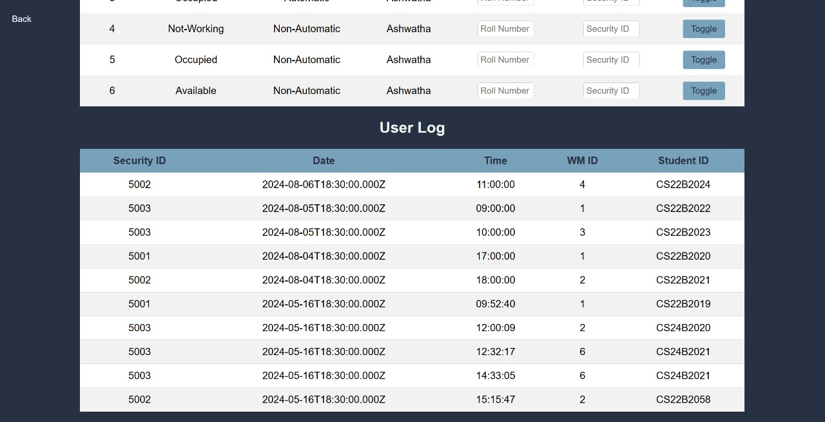

**Maintenance Page:**

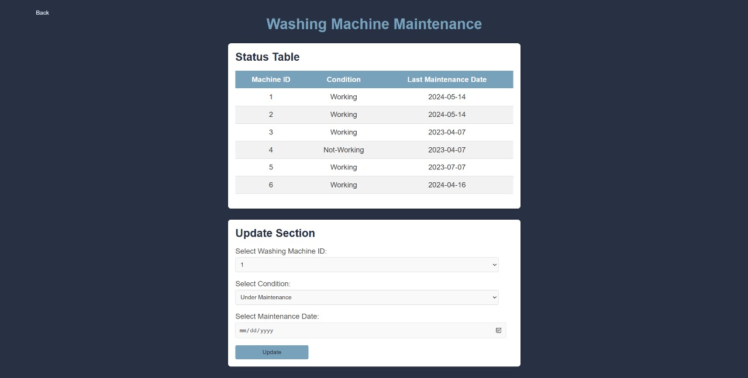

**Feedback Display Page:**

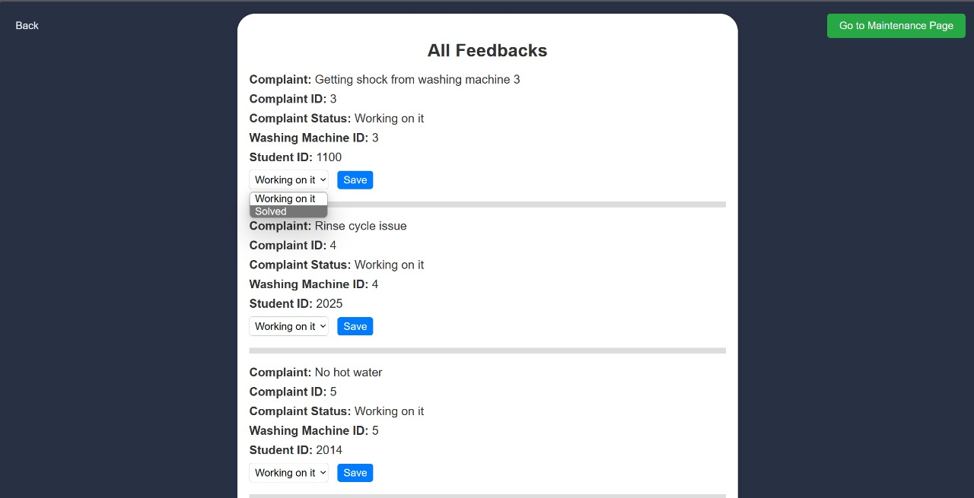

1. **Database**

**Feedback table :** stores feedbacks and complaints given by user

**Attributes :** Complaint,Complaint_ID(Primary Key),Complaint_Status,WM_ID(Foreign key referencing WashingMachine.WM_ID)

,

Student_ID

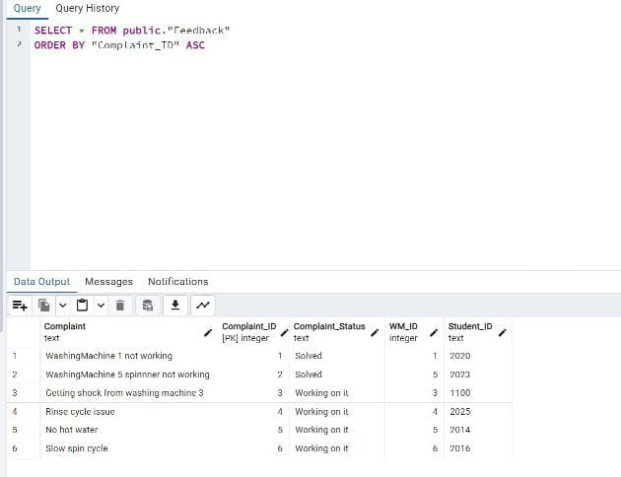

**Status table :** Stores status of each washing machine **Attributes**: Last_Maintainance_Date,Condition,WM_ID(Foreign key referencing WashingMachine.WM_ID)

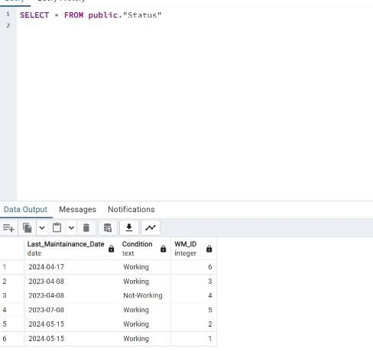

**User_Log table :** Stores complete Logs of users who used washingMachine

**Attributes**: Security_ID(Foreign Key referencing security.security_id ),Date,Time,WM_id(Foreign key referencing WashingMachine.WM_ID),Student_id

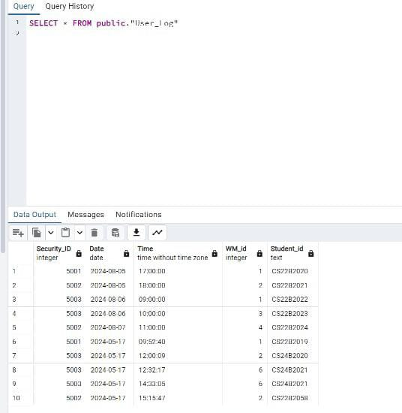

**Login table :** Stores Login details

**Attributes**: UserName(Primary Key),Password

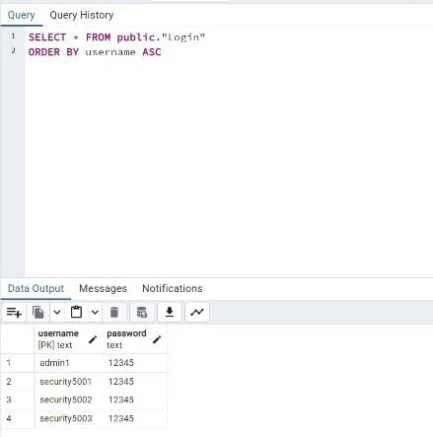

**WashingMachine table :** Stores details and live status(available/occupied) of each washing machine **Attributes**: WM_ID(Primary Key),Live_Status,Type,Location

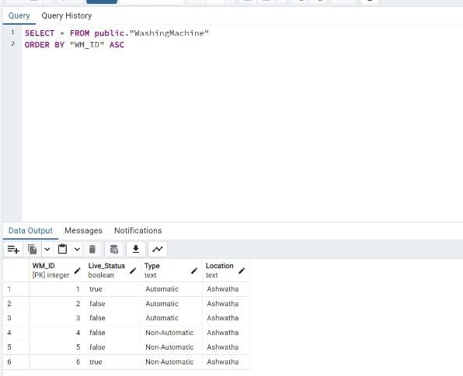

**Security table :** Stores Security_IDs

**Attributes**: Security_ID(Primary Key)

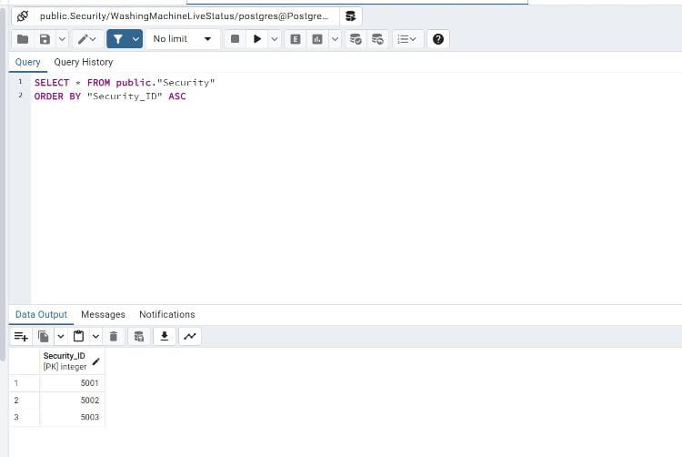

**6 Queries**

For Login:

To check the login credentials, if rows are returned its successful else user will be asked to try again.



To show the live status in landing page:

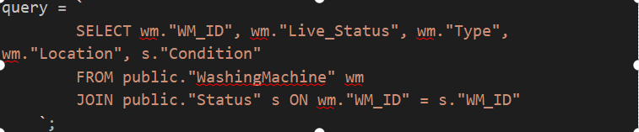

To insert into User Log table:

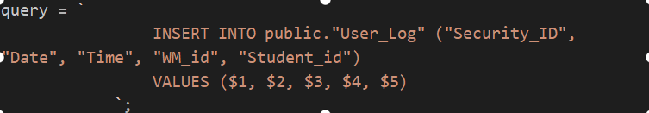

To update the live status of washing machine:



*To register a complaint or feedback:*

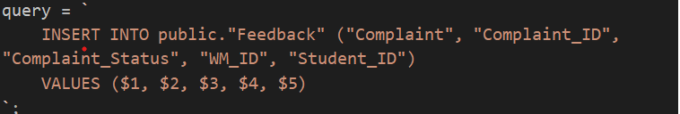

To update the status of the complaint (solved/working on it):



To fetch and display whole data from status table:



To update the status of washing machine in Status table (Under maintenance/Not-Working/Working):



To fetch and show all the logs in user log:

